**New-Bridge Integrated College**

**Year 11-14**

**Study Skills Booklet**



Name: _____________________________

Class: _____________________________

**REVISION TIPS**

Everyone hates revision. It is something that many pupils put off for as long as possible. This result in feeling of guilt, panic and the cry, “There’s not enough time. I wish I’d started my revision sooner.”

The only solution is good planning and time management. This helps you to feel in control.

Revision will only be possible if you good notes and the necessary books. Before you can even plan what you need to revise it is important to check that you have everything you need. If you have got behind with your notes, lost your notes or have difficulty reading your notes, you must beg, borrow or photocopy someone else’s.

Your notes need to be:

* Arranged systematically
* In a separate file for each subject
* Labelled clearly with dividers

**What to Revise**

1. Write down carefully what your teachers tell you to revise
2. If they tell you to revise anything, ask them to suggest what is most important
3. Decide what you know least about or find difficult. Do that first.
4. Make sure you don’t give more time to your favourite subjects whilst neglecting those you hate.
5. Plan a week’s revision on a blank timetable, and then you can see if you’ve included all subjects.

**Prioritise**

* List the topics to be revised for each subject, in your study booklet
* Rearrange the list of topics into order of importance
* Don’t waste time revising topics that you know well
* Cross the weeks off to monitor the passing of time

**LEARNING HOW TO STUDY BETTER**

Motivating yourself to revise is a tough thing to do, so we hope that by reading through this study skills booklet you will pick up some tips which will help you study in a more effective way and increase the amount you learn.

Working through this booklet should enable you to:

1. Identify what type of learner you are
2. What strategies suit your learning style?
3. Draw up a revision timetable for your study day
4. Draw up a schedule for your revision sessions in school
5. Try out different study techniques at home
6. Organise yourself with the right resources
7. Produce a mind map (spidergram) to help with summarising notes
8. Use your memory more effectively
9. Create different mnemonics to help you learn
10. Check out new websites which help you revise

Remember also that everyone is on your side. If you need help with studying, ask a teacher, ask your friends or your parents.

***“The best preparation for tomorrow is doing your best today”***

H Jackson Brown Jr

Good Luck!

**REVISION TIPS – PARENT GUIDE**

*Helping your child through exams*

*(*http://www.bbc.co.uk/schools/helping_with_exams/)

**At a glance**

How to support your child through the stress of revision and exams.

**Assisting with revision**



The secret to doing well in exams lies in planning. You can help your child to create a clear revision plan and method of studying that will make them feel in control of their work.

Tips for Revision Planning:

* Work out a revision timetable for each subject
* Break revision time into small chunks – hour-long sessions with short breaks at the end of each session often work well.
* Make sure your child has all essential books and materials
* Condense notes onto postcards to act as revision prompts
* Buy new stationary, highlighters and pens to make revision more interesting
* Go through school notes with your child or listen while they revise a topic
* Time your child’s attempts at practice papers

**Providing all-round support**

The best way to support your child during the stress of revision and exams is to make home life as calm and pleasant as possible. It helps if other members of the household are aware that your child may be under pressure and that allowances should be made for this.

If your child is given study leave in the run-up to exams, try to be at home as much as possible so that you can share a break and chat together.

Make sure there are plenty of healthy snacks in the fridge and try to provide good, nutritious food at regular intervals. Encourage your child to join family meals, even if it’s a busy revision day – it’s important to have a change of scene and get away from the books and computer for a while. Also encourage your child to take regular exercise. A brisk walk around the block can help clear the mind before the next revision session.

Try not to nag or make too many demands on your child during exam time. Arguments are counter-productive and will only add unnecessary stress and distract from revision.

It’s important to get a good night’s sleep before an exam so discourage your child from staying up late to cram. And make sure he or she eats a good breakfast on the morning of the exam.

----------------------------------------------------------------------------------------------------------------

**Bribes, treats and rewards**

Some children are ‘bribed’ to do well in exams and are offered cash or gifts to achieve good grades. But bribery is not a good idea as it implies that the only worthwhile reward for hard work is money and that you don’t trust your child to work hard. Negative messages like these will affect your child’s sense of worth.

Encourage your child do well for his or her own sake rather than for money or to please you. Explain that exams aren’t an end in themselves but a gateway to the next stage of life – to another Key Stage or to GCSEs, A levels, university, college or work. Good results are themselves the best reward for hard work and will make your child proud of his or her achievements.

Make sure your child knows you’re interested in their work and that you’ll be proud if they do well. Although bribery isn’t advisable, it is fine to provide small treats by way of encouragement – perhaps a piece of cake or some biscuits after a chunk of revision has been completed. The end of exams can be celebrated with a treat that everyone can look forward to, such as a meal out or trip to the cinema.

**REVISION TIPS – STUDENT GUIDE**

Everyone feels nervous about taking exams. Here are some tips to help you make the most of your revision time and keep those nerves under control.

It’s important to remember that an examination is a test of learning, not memory. Examiners want to see evidence that you have drawn on your knowledge to develop a reasoned argument, rather than replicate course notes and textbook facts. Revision should be a process of consolidating understanding rather than cramming as much information as possible before the morning of the exam.

**Study Skills**

**Where to study:**

Creating good conditions to study can help you make the most of the time you spend revising. Here are some suggestions:

* Find a quiet place to study and make sure you are sitting comfortably
* Make sure your desk is well lit
* Keep background noise to a minimum
* Avoid studying in an area where there will be distractions (like televisions!)
* Have everything you need to do your revision to hand before you start.

**How to study:**

There is no ‘right way’ to revise, as long as the method you choose enables you to gain a solid grasp of key facts and consolidate your knowledge. Some students are happy to read their classroom notes from start to finish, others prefers to simplify the information as much as possible, turning everything into skeleton notes, diagrams or mnemonics. In practice, most students find that mixing techniques suits the varied nature of the subjects being revised, and provides essential variety when studying.

* Turn your notes into revision tools;
* Write ideas and facts on to cards to use as ‘prompts’
* Create memory aids such as diagrams or mnemonics (e.g. initial letters to make a word you need to remember or SMART objectives: Specific; Measurable; Achievable; Realistic; Targets). These will help you remember key facts
* Write facts/notes out and display these around the house where you will see them
* Record yourself reading notes to listen to.
* Study with a friend and test each other’s knowledge, but remember you are meeting to revise rather than to chat!
* Work through past question papers – and use a watch or kitchen/egg timer to time them so that you can practise timing your answers.
* Choose study and revision guides sensibly. It’s not hard to find help with revision – as well as established published revision guides, there are hundreds of websites offering help and advice. The problem is not how to find such help, but how to judge which is the best source for your needs. Save valuable time and get recommendations from your teachers.
* Remember the notes you made in class are also a valuable source of extra help
* Keep yourself more alert by changing revision methods during a session. For instance, try switching from note taking to memorising; from reading to asking someone to test you.
* Attend any revision classes that your teachers may be running at school and get their advice on revision methods
* Look after yourself – Sometimes revision can become a competition – who stayed up latest, who worked longest, who’s worrying the most. But the more tired you are less efficiently you’ll work. You need to rest as well as study, eat well, drink lots of water and make sure you pace yourself. Don’t rush, and equally don’t over-revise by doing too much too soon

**2. Revision Plan**

The top tip for successful revision is to make a plan; otherwise it is easy to waste your precious revision time. We recommend that you start your revision at least two weeks before your exams begin. It is helpful to look at your exam dates and work backwards to the first date you intend to start revising.

* List all your exam subjects and the amount of time you think you will need for each one. It is unlikely that the amounts will be equal; Many people find it advisable to allocate more time to the subject or topics they find the most difficult.
* Draw up a revision plan for each week (you can use the ones included in this booklet). Don’t forget to work in some leisure / relaxation time too!
* Fill in any regular commitments you have first, such as sport’s activities or clubs you are involved in, and then the dates of your examinations (see timetable)
* Use revision checklists or Syllabuses for each subject as a starting point. Look at what you need to know and try to identify any gaps in your knowledge. (A good way of doing this is to look at the results of past papers or tests you have worked through)
* Divide your time for each subject into topics based on the units in the revision checklist or syllabus, and make sure you allow enough time for each one.
* Plan your time carefully, assigning more time to subjects and topics you find difficult
* Revise often; try and do a little every day
* Plan in time off, including time for activities which can be done out in the fresh air. Take a 5 or 10 minute break every hour and do some stretching exercises, go for a short walk or make a drink
* You may find it helpful to change from one subject to another at ‘break ’time, for example doing one or two sessions of maths and then changing to Geography or alternating a favourite subject with a more difficult one. It helps to build in some variety.
* Write up your plan and display it somewhere visible (maybe on your bedroom wall, or above your desk wherever that may be)
* Adjust your timetable if necessary and try to focus on your weakest topics and subjects
* Don’t panic; think about what you can achieve, not what you can’t. Positive thinking is important!

**Last-minute revision tips**

Although time may be short, you can still make a difference to your grade. Try and prioritise; do what you can.

Use your revision tools (prompts, diagrams etc) to check final facts

* Keep calm and consolidate your existing knowledge rather than trying to learn new topics
* Don’t stay up all night revision; being overtired will not help you to do your best

**Dealing with exam nerves**

It is natural to feel nervous before an examination. The more prepared you feel, the easier it will be to conquer your fears.

* Use your revision plan to help you feel in control of the process
* Plan your work carefully around the topics you need to focus on. Being aware of gaps in your knowledge can create nerves but having a plan of how you will fill these make you feel better.
* Find out what is involved in each exam:
* Where and when it will take place?
* How much time is allowed?
* How many questions you need to answer?
* What equipment will I need to bring?
* Think positively – you CAN do well
* Keep the exam in context – even if you do badly, there will be other options open to you and you have lots of time to improve before your next exam
* Allow yourself some fun-time each day to relax
* Eat sensibly – your brain cells need energy to function well. Make sure you drink plenty of water to avoid becoming dehydrated. Dehydration makes you tired and reduces concentration.

**Exam tips – sitting the exam**

Be prepared; find out what is involved in each of the examinations that you are going to sit. Organise yourself the night before and get plenty of sleep.

* Check you have the correct equipment with you before you leave the house (pens, pencils, ruler, scientific calculator, etc.)
* Do take a watch or clock so that you can time your answers
* Leave for the exam in plenty of time
* Look through the paper first and mark difficult questions/initial thoughts
* Select the questions carefully so that you will be able to demonstrate your knowledge
* Look at the marks available and read the questions carefully, following instructions given in the paper (e.g. to show all workings, word limits etc)
* Use the information provided on the paper (the answer’s often nearly all there)
* Pace yourself and allow time to answer all the required questions
* Write as neatly as possible to help the examiner to mark your work. Marking untidy writing is difficult
* For longer answers, take a few minutes before you begin to produce a structured plan of what you are going to include in each section
* Allow yourself ten minutes at the end to read through your answers and correct any mistakes
* Cross out anything you do not want the examiner to read (e.g. an earlier answer to a question)

**Exam tips – after the exam**

It is easy to fall into the trap of wondering how well you performed and to discuss this with your fellow students. Your time would be better spent looking ahead to your next examination.

* Don’t panic – you won’t be the only student who is anxious about answers
* Don’t compare your answers with those of other students - this can create negative feelings
* Have some fresh air and food and take time to relax before you start revising
* Don’t rush on your textbooks to check your answers – there is no point at this stage
* Focus on the next exam and how you might improve your exam technique
* Have a quick look at your revision plan. Do you need to adjust it?

Think Positive!

**Do I have the time to study?**

Fill in each ½ hr section with the activity that you do during that time. Use a colour key:

Phone/Friends

T.V. /Computer (games)

Sports/Leisure/Clubs

Eating

Homework Study

Monday

|  |  |
| --- | --- |
| Time | Activity |
| 4.00 p.m. |  |
| 4.30 p.m. |  |
| 5.00 p.m. |  |
| 5.30 p.m. |  |
| 6.00 p.m. |  |
| 6.30 p.m. |  |
| 7.00 p.m. |  |
| 7.30 p.m. |  |
| 8.00 p.m. |  |
| 8.30 p.m. |  |
| 9.00 p.m. |  |
| 9.30 p.m. |  |

Tuesday

|  |  |
| --- | --- |
| Time | Activity |
| 4.00 p.m. |  |
| 4.30 p.m. |  |
| 5.00 p.m. |  |
| 5.30 p.m. |  |
| 6.00 p.m. |  |
| 6.30 p.m. |  |
| 7.00 p.m. |  |
| 7.30 p.m. |  |
| 8.00 p.m. |  |
| 8.30 p.m. |  |
| 9.00 p.m. |  |
| 9.30 p.m. |  |

Wednesday

|  |  |
| --- | --- |
| Time | Activity |
| 4.00 p.m. |  |
| 4.30 p.m. |  |
| 5.00 p.m. |  |
| 5.30 p.m. |  |
| 6.00 p.m. |  |
| 6.30 p.m. |  |
| 7.00 p.m. |  |
| 7.30 p.m. |  |
| 8.00 p.m. |  |
| 8.30 p.m. |  |
| 9.00 p.m. |  |
| 9.30 p.m. |  |

Thursday

|  |  |
| --- | --- |
| Time | Activity |
| 4.00 p.m. |  |
| 4.30 p.m. |  |
| 5.00 p.m. |  |
| 5.30 p.m. |  |
| 6.00 p.m. |  |
| 6.30 p.m. |  |
| 7.00 p.m. |  |
| 7.30 p.m. |  |
| 8.00 p.m. |  |
| 8.30 p.m. |  |
| 9.00 p.m. |  |
| 9.30 p.m. |  |

Friday

|  |  |
| --- | --- |
| Time | Activity |
| 4.00 p.m. |  |
| 4.30 p.m. |  |
| 5.00 p.m. |  |
| 5.30 p.m. |  |
| 6.00 p.m. |  |
| 6.30 p.m. |  |
| 7.00 p.m. |  |
| 7.30 p.m. |  |
| 8.00 p.m. |  |
| 8.30 p.m. |  |
| 9.00 p.m. |  |
| 9.30 p.m. |  |

Saturday

|  |  |
| --- | --- |
| Time | Activity |
| 4.00 p.m. |  |
| 4.30 p.m. |  |
| 5.00 p.m. |  |
| 5.30 p.m. |  |
| 6.00 p.m. |  |
| 6.30 p.m. |  |
| 7.00 p.m. |  |
| 7.30 p.m. |  |
| 8.00 p.m. |  |
| 8.30 p.m. |  |
| 9.00 p.m. |  |
| 9.30 p.m. |  |

Sunday

|  |  |
| --- | --- |
| Time | Activity |
| 4.00 p.m. |  |
| 4.30 p.m. |  |
| 5.00 p.m. |  |
| 5.30 p.m. |  |
| 6.00 p.m. |  |
| 6.30 p.m. |  |
| 7.00 p.m. |  |
| 7.30 p.m. |  |
| 8.00 p.m. |  |
| 8.30 p.m. |  |
| 9.00 p.m. |  |
| 9.30 p.m. |  |

**Metacognition and Thinking Tools**

Study Tools

Really engage in your revision with these recommended visual note taking tools. They have been proven to help students deepen understanding and strengthen their ability to recall key information.

Each **study tool** has an explanation sheet demonstrating how to use them, along with some quick tips on how to make them even more effective.

Use the tools to plan your revision and remember some of the tools will be more effective for you than others.

Find what works for you!!

**Notes**

Note taking Style

# Topic (or question)

|  |  |
| --- | --- |
| **Scribble Pad** | **Short bullet pointed notes** |
| **Recall notes** |

**Summery of notes**

Add key terms, concepts, formulae and any questions to ask of the teacher.

This is where you look back at all the above notes and write a summary.

Cover the above notes and scribble pad notes & try to recall them in this box. This will help you check if you really understand the information. Add thinking and related learning that you may have heard in class or beyond.

**Starting Point** Insert your topic title. Try to be as focused as possible. You may also consider starting with a question. This could be from a past paper.

Focus on the key information. Limit your number of bullet points. Try not to write in everything.

**Summary of notes**

**Recall notes**

**Short bullet pointed notes**

**Scribble Pad**

**Topic (or question)**

strengthen unde

**PURPOSE**

**This method can be used by students to condense and organise important notes.**

The method also involves a requirement to cover and recall key notes which helps

strengthen understanding and faster recall of information.

The method also involves a requirement to cover notes

**QUICK TIP**

Reproduce the structure on an A4 piece of paper. Then try to condense the notes onto that page only. You will have lots of

information to take in.

It’s important to focus on the key information and not just copy everything out.

Target 100-10

# The Question or Topic

**100 Words (Sentences, keywords, phrases) 10 Words (Keywords, phrases)**

# Any questions

**Starting Point**

Insert your topic title or a question (This could be from a past paper. Try to

be as focused as possible).

Select the 10 most significant words from the 100 just written.

The 10 words can then be used to develop acronyms to support memory and faster recall.

Select the 100 most important words written in sentences, keywords and or phrases and insert them here.

The key is not to exceed the 100 word limit.

They can be written as paragraphs or in bullet point form.

Add any questions you may have about the topic or question explored.

**Any questions**

**10 Words (Keywords, phrases)**

**100 Words (Sentences, keywords, phrases)**

**The Question or Topic**

rstanding and faster reca

**QUICK TIP**

When targeting the 100 key words or phrases, try initially recalling them from memory. Read the notes (Text book or teacher handout), engage in some limited highlighting, underlining and/or marginal note taking, and then try to recall the 100 words. See how much was retained and understood. If less than 100 can be recalled go back and read the notes again.

**PURPOSE**

This method can be used by students to condense important notes, by narrowing down on what is really important.

By targeting 100 words students can develop understanding and by targeting 10 words students can strengthen their recall of key information.

Spider Diagram

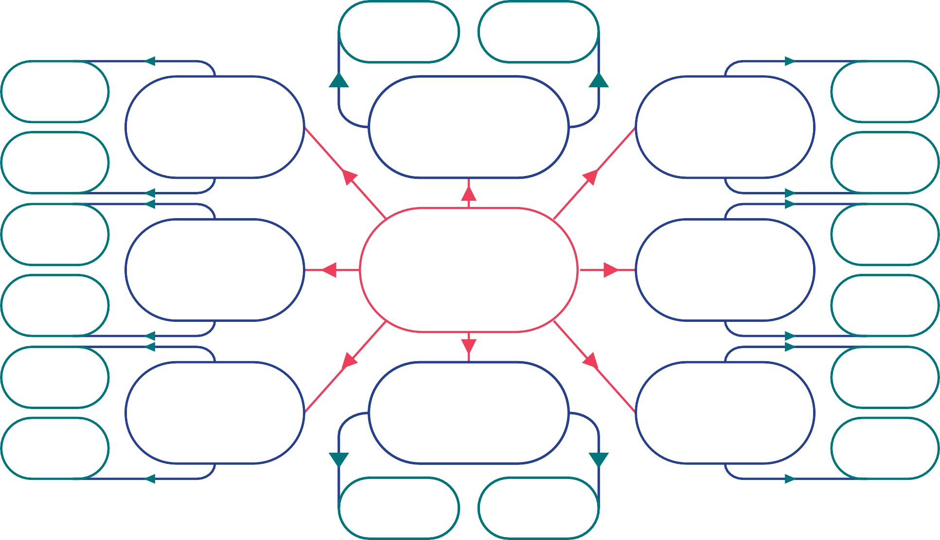

mation.

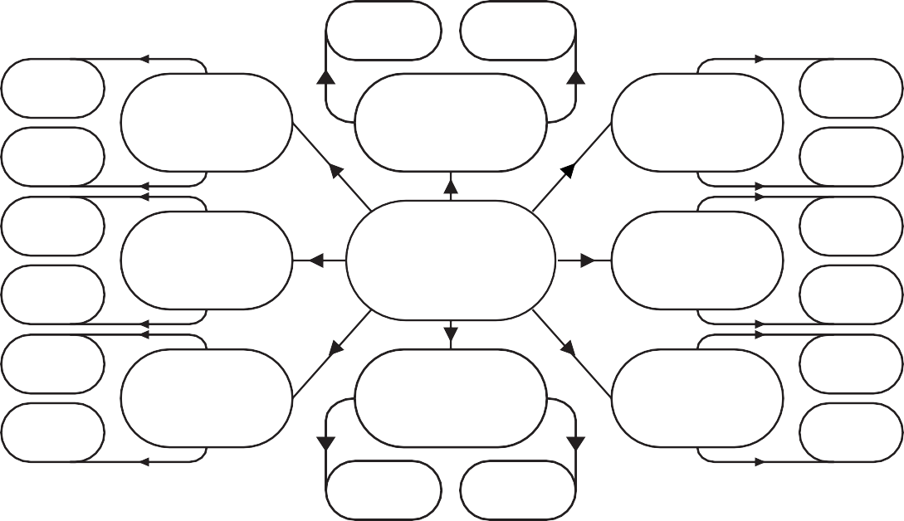

**Starting Point**

Begin with the main concept in the centre. Try to be as specific as possible.

Set out the main points around the main concept breaking it down into clear component parts.

Move out as far as necessary breaking the concept down further and further as you move away from the centre.

Demonstrate the relationship between components with the use of a dashed line.

Even write a comment below the dashed line explaining the relationship.

There is no limit to how far the diagram can expand. However, always seek to ensure the points being noted are as specific as possible and not just repeats of points made elsewhere on the diagram.

**QUICK TIP**

Unlike Mind Maps, where the main focus is on key words and terms, with Spider Diagrams, you can write longer phrases to describe the main points. However, try not to note down too much, you don’t want to overload your memory.

**PURPOSE**

This method can be used by students to organise data and information in a logical way, showing connections and relationships.

It also allows students to explore a concept by breaking it down further and further as they move out from the centre.

**Mind Mapping**



Add as many branches as needed to cover the topic or issue.

**Starting Point**

Begin with a central image. Something that reminds you of the topic or issue being studied. Time to be artistic!!

Key words Key words

& picture & picture

Add thick branches coming from the centre

representing main themes / sections. Add a new branch for each new section. Add as many as needed to cover the topic or issue.

Key words & picture

Add a small picture / doodle that represents the key word or phrase.

From each thick branch draw a thinner branch and add key words and phrases relevant to the section.

Key words & picture

Insert the section title within the actual branch.

**QUICK TIP**

Don’t rush the process of constructing a Mind Map. Add colour to each branch, carefully select the key words and take time to draw or doodle a representative picture. Complete it on a large A3 page (Twice the size of a page you would find in a file block). Put it up on your bedroom wall and look at it daily to support memory and faster recall.

**PURPOSE**

This method can be used by students to explore a topic by breaking it down into component parts (Sections).

Through the use of key words, colour and pictures greater understanding can be developed and faster recall of information achieved.

**The Clock**

**Topic:**

5

**12 1**

**11 2**

**10 3**

**9 4**

5

**8**

**5**

6

7

**7 6**



**Starting Point**

Begin here at 1 o’clock, working around the clock. (Clockwise of course!)

In the margins note down thoughts and reflections. Even develop acronyms to support memory and recall.

**12**

**1**

**11**

**2**

**10**

**3**

In each segment try to only use key words and phrases.

**9**

**4**

**8**

**5**

In the margins fuller explanations can be provided, diagrams can be

written and pictorial representations can be added.

**7**

**6**

Try adding a different colour to each segment to support memory and faster recall.

**QUICK TIP**

Some processes will only have a few stages, e.g. 3 or 4. However to really develop your understanding, why not try to get the whole way around the clock by breaking down the process into smaller and smaller steps.

**PURPOSE**

This method can be used by students to develop their understanding of cyclical processes.

By filling in each segment of the clock with a part of the process in the order that it occurred, working from 1 to 12, the student develops their understanding and strengthens their ability to recall the key information.

**The Circle Cycle**

Starting Point

Begin with the first stage/step of the process or sequence. Then follow one after the other.

Try colouring each circle to support memory and recall.

**1st**

**4th**

**2nd**

Try and stick to key words and phrases. Avoid writing too much text.

Each stage / step doesn’t have to be presented within a circle, they can be shown in a rectangle or any shape you want.

**3rd**

Note down any additional learning you can recall from class notes, textbooks, general thoughts or reflections.

**QUICK TIP**

As many circles as required can be added depending on the process. However, it’s useful not to add too many as it may overload memory.

**PURPOSE**

This method can be used by students to explore a topic by breaking it down into component parts (Sections).

Through the use of key words, colour and pictures greater understanding can be developed and faster recall of information achieved.

**Timeline**

# 1st 3rd 5th 7th 9th

**Topics:**

**2nd 4th 6th 8th**



Detail the events along the timeline, moving from left to right.

**1st**

**3rd**

**5th**

**7th**

**9th**

Try adding colour to each box to support memory and faster recall.

**Topic:**

**2nd**

**4th**

**6th**

**8th**

**Starting Point**

Insert the topic title. Try to be as specific as possible.

The timeline can run as long as you need. However, it’s better to keep it shorter to aid memory and recall.

**QUICK TIP**

Note down any additional learning you can recall in the margins from class discussions, general thoughts or reflections. For example, you may have read something or seen something on a documentary that could be added.

**PURPOSE**

This method can be used by students to show specific events in sequence, usually with dates moving from left to right.

It is very useful for developing understanding of historical events as it allows major events to be displayed over a period of time.

**Compare and Contrast Diagram**

**Topic: __________________________________________________________________________**

**Concept A**

**Concept B**

**Similarities**

**Differences**

Concept A

**Starting Point**

Note down the names of

concept A and concept B.

**Concept A**

**Concept B**

**Similarities**

Identify the similarities between the two concepts.

Note down the ways

they are different.

**Differences**

Note down how they would be different for Concept A.

~~No~~te down how they

would be different

~~Co~~ncept B.

**QUICK TIP**

Try and use key words and phrases. Avoid Large amounts of texts, i.e simply rewriting your notes onto this structure.

Try to use key words and phrases. Avoid large amounts of text, i.e. simply rewriting your

notes onto this structure.

Tr

key words and phrases. Avoid large amounts of text, i.e. simply rewriting your

notes onto this structure.

T T

y to use key words and phrases. Avoid large amounts of text, i.e. simply rewriting your

notes onto this structure.

y to use key words and phrases. Avoid large amounts of text, i.e. simply rewriting your

notes onto this structure.

Try to use key words and phrases. Avoid large amounts of text, i.e. simply rewriting your

notes onto this structure.

**PURPOSE**

This method can be used by students to explore the similarities and differences between two concepts or issues.

This lined approach can suit some learners who don’t like the unstructured approach offered by the traditional circle-based Venn Diagram.

**Venn Diagram**



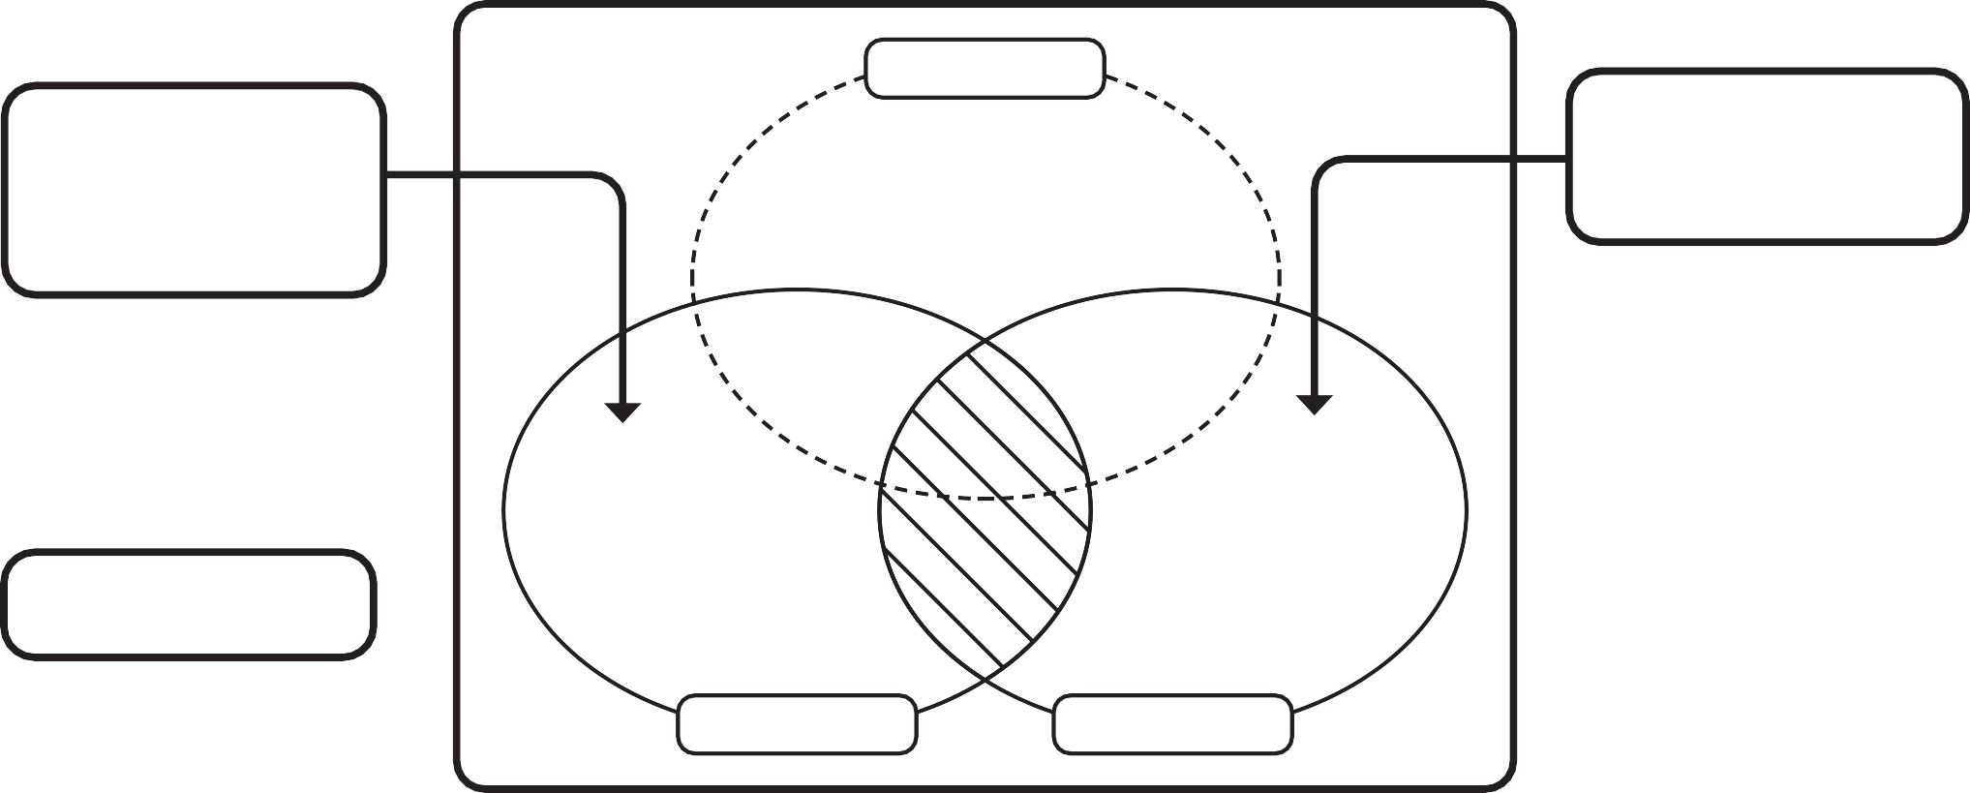

**CONCEPT**

**Starting Point**

Place the unique characteristics or variables of one of the concepts here. These are the differences.

Place the unique characteristics or variables of one of the concepts here. These are the differences.

Identify the similarities between the concepts here.

Add additional thoughts and considerations here in the margins. Highlight

examples and questions for further consideration.

**CONCEPT**

**CONCEPT**

**QUICK TIP**

Traditionally Venn Diagrams only have 2 circles allowing two concepts to be compared. However, additional circles can be added to identify similarities and differences.

Try to use key words and phrases. Avoid large amounts of text, i.e. simply rewriting your

notes onto this structure.

Tr

key words and phrases. Avoid large amounts of text, i.e. simply rewriting your

notes onto this structure.

T T

y to use key words and phrases. Avoid large amounts of text, i.e. simply rewriting your

notes onto this structure.

y to use key words and phrases. Avoid large amounts of text, i.e. simply rewriting your

notes onto this structure.

Try to use key words and phrases. Avoid large amounts of text, i.e. simply rewriting your

notes onto this structure.

**PURPOSE**

This method can be used by students to show the relationships (Similarities and differences) among things or finite groups of things.

Traditionally used to show the relationship between two concepts, additional circles can be added to show multiple relationships.

**Venn Diagram 2**

Difficulties Similaries Difficul

**Concept A Concept B**

**Difficulties Similarities** **Difficulties**

**Starting Point**

Name the concept to be compared and list the unique characteristics or variables.

**Concept A**

Differences

Similarities

**Concept B**

Differences

Name the concept to be compared and list the unique characteristics or variables.

Identify the similarities between the concepts here.

Similarities

**Essay Planner**

**QUICK TIP**

Try to avoid writing out long paragraphs, focus on key words and short phrases. This can avoid memory overload and support faster recall.

Try to use key words and phrases. Avoid large amounts of text, i.e. simply rewriting your

notes onto this structure.

Tr

key words and phrases. Avoid large amounts of text, i.e. simply rewriting your

notes onto this structure.

T T

y to use key words and phrases. Avoid large amounts of text, i.e. simply rewriting your

notes onto this structure.

y to use key words and phrases. Avoid large amounts of text, i.e. simply rewriting your

notes onto this structure.

Try to use key words and phrases. Avoid large amounts of text, i.e. simply rewriting your

notes onto this structure.

**PURPOSE**

This method can be used by students to show the relationships (Similarities and differences) among concepts.

This lined approach can suit some learners who don’t like the unstructured approach offered by the traditional Venn Diagram.

**Title**

**Introduction**

**1st Paragraph**

**2nd Paragraph**

**3rd Paragraph**

**Conclusion**

**PURPOSE**

This method can be used by students to provide structure when writing essays and extended pieces of writing.

It allows arguments to be clearly set out, allowing an evaluative conclusion to be formed.

CC

**Starting Point** Begin with the title. This may be an essay title from a past paper.

**Title**

Set out the 3 main points in each of the boxes. Then explain each point in as much detail as possible.

**1st Paragraph**

**3rd Paragraph**

Set out the introduction paragraph. Tell the reader what the essay will be about. Try to engage the reader’s interest right from the start.

**Conclusion**

Set out the concluding paragraph. Try to summarise your main points and restate key ideas or points of view. It’s always good to leave the reader with a parting thought.

**Conclusion**

**Introduction**

**2nd Paragraph**

**QUICK TIP**

Even though it’s called the ‘5 Paragraph Essay Planner’, it can actually have as many paragraphs as required.

Try to use key words and phrases. Avoid large amounts of text, i.e. simply rewriting your

notes onto this structure.

Tr

key words and phrases. Avoid large amounts of text, i.e. simply rewriting your

notes onto this structure.

T T

y to use key words and phrases. Avoid large amounts of text, i.e. simply rewriting your

notes onto this structure.

y to use key words and phrases. Avoid large amounts of text, i.e. simply rewriting your

notes onto this structure.

Try to use key words and phrases. Avoid large amounts of text, i.e. simply rewriting your

notes onto this structure.

**On the Other Hand**

**Conclusion**

**Essay Title**

**I agree because… I disagree because…**

**1st 2nd 3rd 1st 2nd 3rd**

# 



Evaluative conclusion. Begin with:

*‘Overall I agree or disagree with the statement to_______extent because .’*

Provide an explanation as to the points of disagreement. Explain each point in detail.

# Starting Point Set out precisely why you

Insert the essay title. Essay Title disagree

It can be taken directly

from a past paper

**I agree because … I disagree because…**

**1st 2nd 3rd 1st 2nd 3rd 1**

Set out precisely

why you agree.

Provide an explanation as

to the points of agreement. **Conclusion**

Explain each point in detail

**1st**

**QUICK TIP**

Once the table is completed, directly use it to write the essay. Then on the following, or a different night try completing the essay without it to see the level of detail you can recall. Even try it under timed conditions.

Try to use key words and phrases. Avoid large amounts of text, i.e. simply rewriting your

notes onto this structure.

Tr

key words and phrases. Avoid large amounts of text, i.e. simply rewriting your

notes onto this structure.

T T

y to use key words and phrases. Avoid large amounts of text, i.e. simply rewriting your

notes onto this structure.

y to use key words and phrases. Avoid large amounts of text, i.e. simply rewriting your

notes onto this structure.

Try to use key words and phrases. Avoid large amounts of text, i.e. simply rewriting your

notes onto this structure.

**PURPOSE**

This method can be used by students to provide structure when writing essays and extended pieces of writing.

It allows arguments to be clearly set out leading to a clear evidence-based conclusion.

**Fishbone Diagram**

**Main topic**

**Main Topic**

Each one of these smaller

bones can be broken down further as required to develop understanding.

**Starting Point**

Add the main topic to

be studied. Try to be specific as possible.

Break each section down into parts. Focus on

key words and phrases. Avoid just copying notes across. Add as many small bones as required.

into sections labelling a section with a key word or phrase. Add as many additional sections as needed. This chunking of information supports memory and recall.

into sections labelling a section with a key word or phrase. Add as many additional sections as needed. This chunking of information supports memory and recall.

Break the topic down into sections labelling a section with a key word or phase. Add as many additional sections as needed. This chunking of information supports memory and recall.

into sections labelling a section with a key word or phrase. Add as many additional sections as needed. This chunking of information supports memory and recall.

s labelling a section with a key word or phrase. Add as many additional sections as needed. This chunking of information supports memory and recall.

vbvbvbvbvbvbbrerere

into sections labelling a section with a key word or phrase. Add as many additional sections as needed. This chunking of information supports memory and recall.

into sections labelling a section with a key word or phrase. Add as many additional s into sections labelling a section with a key word or phrase. Add as many additional sections as needed. This chunking of information supports memory and recall.

ections as needed. This chunking of information supports memory and recall.

into sections labelling a section with a key word or phrase. Add as many additional sections as needed. This chunking of information supports memory and recall.

into sections labelling a section with a key word or phrase. Add as many additional sections as needed. This chunking of information supports memory and recall.

into sections labelling a section with a key word or phrase. Add as many additional sections as needed. This chunking of information supports memory and recall.

into sections labelling a section with a key word or phrase. Add as many additional sections as needed. This chunking of information supports memory and recall.

tions labelling a section with a key word or phrase. Add as many additional sections as needed. This chunking of information supports memory and recall.

**QUICK TIP**

Try adding a different colour to each bone section to make them stand out and to support memory and faster recall. You could even add pictures or images to represent the key words and phrases.

Try to use key words and phrases. Avoid large amounts of text, i.e. simply rewriting your

notes onto this structure.

Tr

key words and phrases. Avoid large amounts of text, i.e. simply rewriting your

notes onto this structure.

T T

y to use key words and phrases. Avoid large amounts of text, i.e. simply rewriting your

notes onto this structure.

y to use key words and phrases. Avoid large amounts of text, i.e. simply rewriting your

notes onto this structure.

Try to use key words and phrases. Avoid large amounts of text, i.e. simply rewriting your

notes onto this structure.

**PURPOSE**

This method can be used by students to explore a topic by breaking it down into smaller component parts. This helps to develop and strengthen recall of important information.

Elaborative Interraggation Table

# Statement / Comments / Topic Heading

**Why... Answer**

# How... Answer

**Why... Answer**

**Starting Point**

Begin with a statement or comment, e.g., ‘Plants need oxygen, water and

sunlight for the process of photosynthesis to occur’. A topic heading could also be used. These can be found in text books

or subject specifications. You are looking for a statement about the topic being studied.

Think about the types of questions that could be asked about this statement or comment in an exam.

Note them down in these boxes. The only requirement is that the questions must begin with ‘Why’ or ‘How’.

You can add as many ‘why’ and ‘how’

questions as required.

**Answer**

**Why... or how...**

**Answer**

**Why...**

**Answer**

**How...**

**Answer**

**Why...**

When answering the

questions, you can make

reference to your notes or

try to recall the information

Once you have

from memory, only looking Completed the questions

back at your notes to check you then proceed to answer

if you were correct. the questions

**QUICK TIP**

Work through this process over a few nights of revision. On the

first night read through the notes. Highlight the most important information. Then attempt to write the questions using the question starters ‘Why’ and ‘How’. The next, or another, night have a go at answering the questions.

Try to use key words and phrases. Avoid large amounts of text, i.e. simply rewriting your

notes onto this structure.

Tr

key words and phrases. Avoid large amounts of text, i.e. simply rewriting your

notes onto this structure.

T T

y to use key words and phrases. Avoid large amounts of text, i.e. simply rewriting your

notes onto this structure.

y to use key words and phrases. Avoid large amounts of text, i.e. simply rewriting your

notes onto this structure.

Try to use key words and phrases. Avoid large amounts of text, i.e. simply rewriting your

notes onto this structure.

**PURPOSE**

This method can be used by students to explore a topic at the analytical (Analysis) and evaluative (Evaluation) level.

At the centre of the method is asking questions about ‘how’ and ‘why’ things work and then producing answers to these very questions. The ‘Why’ questions

encourage analytical thinking, and the ‘How’ questions evaluative thinking. Both higher order thinking skills.

**Problem/Solution Diagram**

**Your Problem**

**Choice 1**

**Choice 2**

**Choice 3**

**Pros**

**Cons**

**Pros**

**Cons**

**Pros**

**Cons**

**Your Solution**

Present the various choices to solving the problem. There is a room for 3 choices. However, more ‘choice boxes can be added if needed. Just be sure you are not repeating the same ones

Finally, note down your solution having followed the steps. A summary of the reasons for your final choice can be added as well as your reasons for not choosing the others

When highlighting the advantages and disadvantages make reference

to your notes and other thoughts and considerations.

Explore the advantages (Pros) and disadvantages (Cons) of each f the choices.

**Pros**

**Cons**

**Pros**

**Cons**

Starting Point

State the problem here, e.g. Global warming, Over

population growth, Achieving gender equality, to name

but a few. It could even be a past paper question.

**Your Problem**

**Choice 1 Choice 2 Choice 3**

**Pros**

**Cons**

Your Solution

**Your Solution**

**PURPOSE**

This method can be used by students to explore various choices (and options) to solving a problem.

It allows each possible approach to be analysed by looking at the ‘pros’ and ‘cons’ before presenting a final evidence-based conclusion. It supports the writing of essays or extended pieces of writing.

**QUICK TIP**

Try completing the diagram with someone else from your class. You can both agree the choices available and one of you can consider the ‘Pros’ and the other the ‘Cons’. Then, debate the solution.

Try completing the diagram with someone else from you class. You can both agree the choices available and then one of you can consider the ‘Pros’ and the other the ‘Cons’. Then, debate the solution.

Try completing the diagram with someone else from you class. You can both agree the choices available and then one of you can consider the ‘Pros’ and the other the ‘Cons’. Then, debate the solution.

Try to use key words and phrases. Avoid large amounts of text, i.e. simply rewriting your

notes onto this structure.

Tr

key words and phrases. Avoid large amounts of text, i.e. simply rewriting your

notes onto this structure.

T T

y to use key words and phrases. Avoid large amounts of text, i.e. simply rewriting your

notes onto this structure.

y to use key words and phrases. Avoid large amounts of text, i.e. simply rewriting your

notes onto this structure.

Try to use key words and phrases. Avoid large amounts of text, i.e. simply rewriting your

notes onto this structure.

**Step by Step Diagram**

# Topic:

**State the Problem:**

**Add formulas, notes and questions.**

**Stage 1:**

**Stage 2:**

**Stage 3:**

**Stage 4:**

**Stage 5:**

**Your Solution:**

**Starting Point**

State the problem here. This can be a Maths or Science problem. It can be a past paper question.

**Add formulas, notes and questions.**

**State the Problem:**

Add in formulas, notes and questions.

**Stage 1:**

Note down each of the steps required to solve the problem. There is space for 6 steps, however more can be added if required.

**Stage 2:**

**Stage 3:**

**Stage 4:**

**Stage 5:**

**Your Solution:**

Finally, note down your solution having followed the steps.

**QUICK TIP**

In the ‘Add formulas, notes and questions section’ note down common mistakes or assumptions that could be made when answering questions like this. This can be a good reminder when it comes to answering a similar question in an exam.

Try completing the diagram with someone else from you class. You can both agree the choices available and then one of you can consider the ‘Pros’ and the other the ‘Cons’. Then, debate the solution.

Try to use key words and phrases. Avoid large amounts of text, i.e. simply rewriting your

notes onto this structure.

Tr

key words and phrases. Avoid large amounts of text, i.e. simply rewriting your

notes onto this structure.

T T

y to use key words and phrases. Avoid large amounts of text, i.e. simply rewriting your

notes onto this structure.

y to use key words and phrases. Avoid large amounts of text, i.e. simply rewriting your

notes onto this structure.

Try to use key words and phrases. Avoid large amounts of text, i.e. simply rewriting your

notes onto this structure.

**PURPOSE**

This method can be used by students to set out the steps required to arrive at a solution to a problem. By clearly setting out the steps, mistakes can be avoided. Traditionally used for Maths and Science type problems, however it can be used to solve problems relating to social, environmental and global issues, e.g. Over population growth, Climate change, etc.

**Fishbone Diagram (Cause and Effect)**

**Starting Point** Identify the problem / outcome / effect you want to study.

Break each section down into parts. Focus on

key words and phrases. Avoid just copying notes across. Add as many small bones as required.

Break the possible causes

down into sections

labelling a section with a

key word or phrase. Add

as many additional bones

as needed depending on

the number of sections

required. This chunking

of information will

support memory and

recall.

Add as many boxes

as required. Although

be sure it’s not just a

repeat of another

cause.

**PURPOSE**

This method can be used by students to explore the likely causes of an effect (Outcome or event).

Once the possible or probable causes have been identified students can consider what they see as the root cause(s) and reach an evaluative conclusion.

**QUICK TIP**

Try adding a different colour to each bone section to make them stand out and to support memory and faster recall. You could even add pictures or images to represent the key words and phrases.

Try completing the diagram with someone else from you class. You can both agree the choices available and then one of you can consider the ‘Pros’ and the other the ‘Cons’. Then, debate the solution.

Try to use key words and phrases. Avoid large amounts of text, i.e. simply rewriting your

notes onto this structure.

Tr

key words and phrases. Avoid large amounts of text, i.e. simply rewriting your

notes onto this structure.

T T

y to use key words and phrases. Avoid large amounts of text, i.e. simply rewriting your

notes onto this structure.

y to use key words and phrases. Avoid large amounts of text, i.e. simply rewriting your

notes onto this structure.

Try to use key words and phrases. Avoid large amounts of text, i.e. simply rewriting your

notes onto this structure.

**TIMETABLES AND PLANNERS**

The last section of this booklet is all about Timetables and Planners. So far we have heard lots about how important it is to prepare for exams and your timetables and planners should help with this preparation.

* The first thing you will need is a copy of your Exam Timetable – this will let you know what day and at what time each of your exams will be happening.

* Transfer this timetable onto your ‘My exam timetable planner’ so that it is more personalised for you.
* Next you need to think about how you can make best use of the coming weeks. There are three Revision Timetables included so you can plan out what you will be doing each day and evening.
* Finally there is a planner called ‘My Study Day’ which will help you to organise the study day you have at home to ensure you make the most out of this time. There are two copies of it in case you make a mistake or need to change anything.

At the end you will also find a few pages to use for the Revision Lists you will be given in each class. Make sure you fill them in carefully so that you know exactly what you are expected to learn.

**MY STUDY DAY**

This is my Revision Schedule for my Study Day

|  |  |  |  |
| --- | --- | --- | --- |
| **TIME** | **SUBJECT** | **TOPIC** | **TICK WHEN COMPLETED** |
| 9.00-9.40 |  |  |  |
| 10.00-10.40 |  |  |  |
| 11.00-11.40 |  |  |  |
| 12.00-12.40 |  |  |  |
| 1.00-1.40 |  |  |  |
| 2.00-2.40 |  |  |  |
| 3.00-3.40 |  |  |  |
| 4.00-4.40 |  |  |  |
| 5.00-5.40 |  |  |  |
| 6.00-6.40 |  |  |  |
| 7.00-7.40 |  |  |  |

*Sometimes easier to study in 40 minute blocks but remember to include plenty of*

*breaks in between!*

**MY EXAM TIMETABLE PLANNER**

|  |  |  |  |  |
| --- | --- | --- | --- | --- |
| DATE | 9.10-10.30 | 10.50-12.10 | 12.45-2.00 | 2.00-3.20 |
|  |  |  |  |  |
|  |  |  |  |  |
|  |  |  |  |  |
|  |  |  |  |  |
|  |  |  |  |  |

Notes

____________________________________________________________________________________________________________________________________________________________________________________________________________________________________________________________________________________________________________________________________________________________________________________________________________________________________________________________________________________________________________________________________________________________________________________________________________________________________________________________________________________________________________________________________________________________________________________________________________________________________________________________________________________________________________________________________________________________________________________________________________________________________________________________________________________________________________________________________________________________________________________________________________________________________________________________________________________________________________________________________________________________________________________________________________________________________________________________________________________________________________________________________________________________________________________________________________________________________________________________________________________________________________________________________________________________________________________________________________________________________________________________________________________________________________________________________________________________________________________________________________________________________________________________________________________________________________________________________________________________________________________

**KEEPING YOU INFORMED**



New-Bridge Integrated College have a variety of communication methods using social media which parents /guardians can access to keep up to date on all aspects of the College life.

**WEBSITE**

We have an active website which provides a range of information on Curriculum, Leavers destinations, School Policies, Admissions, Primary Roadshow Lesson, Parent information, School Events, News Items and Much More. Visit our webpage https://[www.newbridgeintegrated.org](http://www.newbridgeintegrated.org)

**FACEBOOK**

Please like us on Facebook to receive regular updates;

https://www.facebook.com/newbridgeintegrated.org

**Instagram**

We are now on Instagram!

Instagram: @newbridgeintegrated

**Twitter**

Twitter @NewbridgIC

NEW-BRIDGE INTEGRATED COLLEGE

25 Donard View Road

Loughbrickland

BT32 3LN

Telephone: 028 4062 5010

email: info@newbridgecollege.loughbrickland.ni.sch.uk