New-Bridge Integrated College
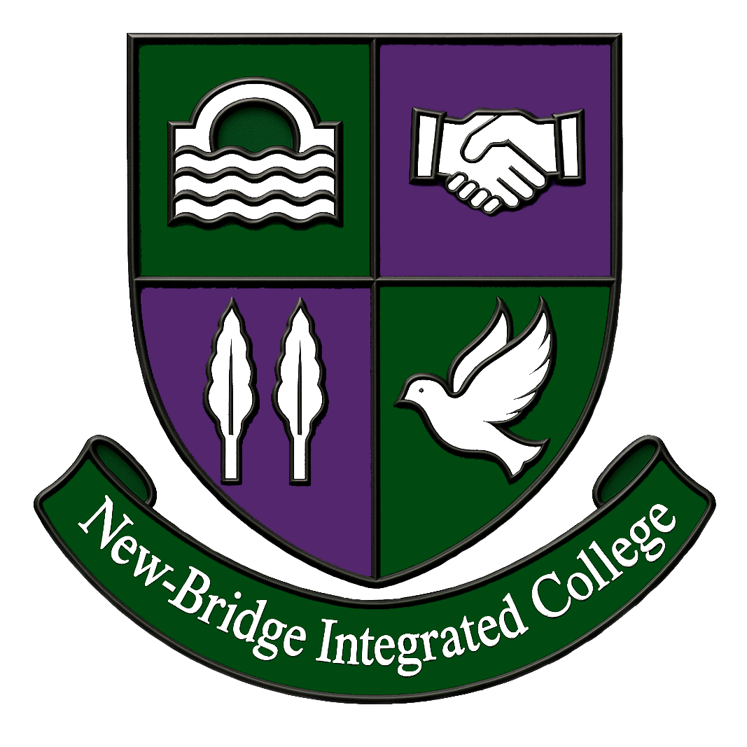
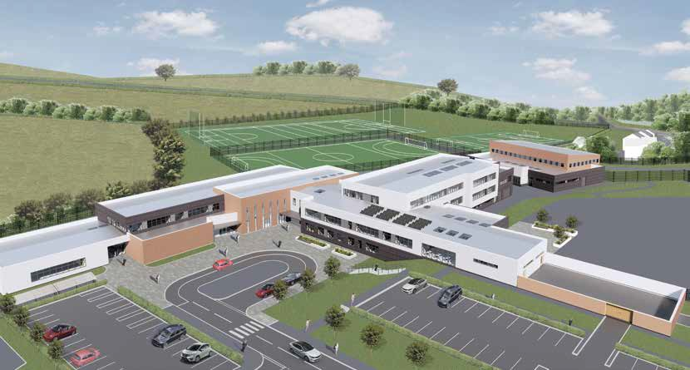

“The School for all the Family”

April 2026

APPOINTMENT OF PRINCIPAL

Thank you for your interest in the post of Principal at New-Bridge Integrated College

Following the retirement of the present Principal, Anne Anderson, the Board of Governors seeks to appoint an innovative and strong leader who will build on the strengths of the College and take the school forward in our wonderful state of the art new building. The successful candidate will demonstrate a positive commitment to integrated education and inclusive child centred education. The appointment will take effect from 1 September 2026.

If you wish to be considered for this post, please complete the application form and provide the additional information requested, using for guidance, the Person Specification included in this pack.

The closing date for applications is Noon on Friday 24 April 2026

Shortlisted candidates will be invited to a visit to the school on Wednesday 29 April from 4pm onwards and will attend for interview on Friday 1 May 2026. Candidates selected at this stage may be invited for a second interview.

I look forward to receiving your application form by noon on Friday 24 April 2026.

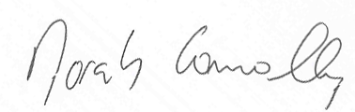
.........................................................
Norah Connolly
Chairperson, Board of Governors

Contents of the Pack

College Vision, Mission and Core Values
College Background Information
Selection and Appointment Process
Job Description Annex A
Person Specification Annex B
Information on Terms and Conditions of Employment Annex C

Other documentation
Application Form
Equal Opportunities Monitoring Form

A copy of our Prospectus is available on our school website www.newbridgeintegrated.org

A Copy of our Recent Inspection Report is linked below:

https://www.etini.gov.uk/publications/report-post-primary-inspection-new-bridge-integrated-college

COLLEGE VISION AND MISSION

Our Vision:
“New-Bridge Integrated College is an integrated all-ability school, welcoming children of all faiths and traditions. We are committed to ensuring that all our pupils are provided with the opportunity to achieve to their full educational potential in a challenging and stimulating environment in which they all feel cherished and valued”

Our College Aims:
- To enable our pupils to grow mature in their own beliefs, culture and tradition
- To promote peace and reconciliation by actively seeking knowledge and understanding of other beliefs, cultures and traditions
- To develop in our pupils the self-esteem and self-discipline necessary for responsible citizenship in a pluralistic society
- To provide a challenging and stimulating environment in which the academic, sporting and personal success of pupils is promoted and celebrated
- To cherish, nurture and respect each other regardless of race, gender or other differences
- To encourage individual spiritual development and to work and pray for peace in our lives
- To promote the involvement of all members of the College community, whether governors, parents, pupils or staff in the development of the College
- To foster a caring and responsible attitude to the College and the local environment
- To create effective links between the College and the wider community

Our Core Values:

At New-Bridge our rules and policies are based on our three Core Values –
- Ready
- Responsible
- Respectful

These Core Values underpin all that we do, and we work together to actively promote our Integrated ethos through the creation of an atmosphere of mutual respect, which can be achieved through courtesy and concern for others.

Our School Motto:

“the school for all the family”

We recognise the value in others and
appreciate the support
and opportunities we are given.
We encourage persistence and determination, helping pupils develop the strength to bounce back and learn from challenges.
We provide a wide range of academic, creative, and extracurricular opportunities that are inclusive for all.
We inspire curiosity and a lifelong love of learning, sparking the natural drive to question, explore, and create

Section 1: COLLEGE BACKGROUND INFORMATION

Introduction

New-Bridge Integrated College is an 11–18 school, which welcomes boys and girls, all abilities, and families from catholic, protestant and other traditions. We have 693 students and 91 members of teaching and support staff. Our school was established in 1995 by parents from the Banbridge and Newry areas, who wanted a school where children from different communities could be educated together, every day, under one roof.

As the Evens Foundation ‘Laureate of Peace Education’, we continue to play a significant role in promoting our inclusive ethos, as we not only recognise our accomplishments as an all-ability school, but also our role as peacebuilders; celebrating Integrated Education at its best. We reflect on the well-rounded individuals our students have become, respectful of other traditions and cultures, as they, like so many, have benefited from an authentic integrated experience. Our integrated ethos underpins all our interactions, our relationships, our decisions and also in our curriculum design as we operate tailored pathways for our students in KS3, KS4 and Post 16.

The many awards our school has won over the years is testimony to a whole community approach to education; and our inclusive spirit is reflected in our:

- NICIE ‘Excellence in Integration Award
- Children in Crossfire Gold Compassion Award
- Rights Respecting School Gold Award
- Families First Outstanding Pastoral Care Award
- School of Sanctuary Award
- Evens Foundation Laureate of Peace Education
- Goldsmith Community Engagement Award
- Aware NI Investors in Mental Health Award
- Paul Dix ‘When the Adults Change’ Partner School

It is our whole school approach to nurture and restorative practices, along with our relational based approach to teaching and learning, that has enabled our school to become the first school in Northern Ireland to be recognised as a Paul Dix ‘When the Adults Change Partner school’.

Individual successes can also be attributed to the wider enrichment experiences our students are able to access at New-Bridge and the many external collaborations which supports our work in building student leadership capacity.

- Our Taking Boys Seriously research work with Ulster University has played a role in maximising our boys potential
- Our Scholar's Programme “The Brilliant Club” which is a collaboration with Queens’ University, Belfast has provided a unique insight into university practices and has enabled our students to make a smooth transition into university life.
- Our Business Mentorship programmes through our ‘Business Experience’ and ‘Sisters IN’ Programme provides an additional layer of careers guidance for our students as it builds stronger connections between business and school
- Our outreach primary schools programme has provided opportunities for so many New-Bridge students to prepare and deliver lessons, to primary students, enabling primary students to access specialist learning on a range of subject topics which in turn helps strengthen our community connections
- Our work as a ‘Catalyst School’ has upskilled staff on design thinking practices to further enhance the learning experiences of our students , extending beyond the classroom.
- Our Cross Border Projects, funded through Department of Foreign Affairs Reconciliation Fund enables our pupils and staff to work together on projects around identity and social change.
- Our JOLT (Joy of Learning Together) Project Based Learning Programme develops our students youth advocacy skills .A programme which has gained the formal recognition of the Social Impact Award as well as the Road Safety Partnership Post Primary Award for 2025.

Our School is a member of the Banbridge Area Learning Community of 6 post primary schools where there is active collaboration between the schools to develop and strengthen curriculum and pastoral work across the community.

At New-Bridge we provide high quality education through a broad and balanced curriculum which caters for the full ability range. With over 30 GCSE/Vocational subjects on offer and 3 tailored pathways to meet the full ability range and 24 subjects on offer at A Level, our New-Bridge students continue to progress to high demand courses at university as well as Higher Level Apprenticeship Programmes. We are very proud of our excellent record of academic and vocational success which ensures progression for all our young people. We are proud to say that our dedicated and committed staff offer many opportunities for each student to achieve their full potential and we celebrate the ‘personal best’ of every student at New-Bridge. Our child centred approach to learning and teaching is built on positive relationships between staff, students, and parents; with priority given to the care and welfare of our students.

This is a very exciting time to join New-Bridge and we are looking forward to welcoming our new Year 8 students in 2026. We have moved into our state of the art new school building which is already bringing many benefits to our entire school community. Our cutting-edge sports facilities enable us to enhance our current extra-curricular menu of Gaelic football, football, hockey, camogie, netball, rugby and orienteering, to name but a few.

New-Bridge is a happy place to learn and work. Our school motto ‘The School for All the Family’ highlights that we celebrate every success story of every student every day at New-Bridge. We have high standards and high expectations, asking that everyone works and learns to their full potential, everyone helps those around them to do their best and every student develops into a thoughtful and caring member of her or his community. It is our integrated ethos; that sense of belonging and our capacity to care which has made our school the success story it is today.

Our students leave us ready to play a key role in change for the better, because they have had the privilege of an integrated education and they understand in practice the values of respect, compassion and tolerance.

.

Section 2: SELECTION AND APPOINTMENT PROCESS

The Board of Governors of New-Bridge Integrated College wish to appoint a Principal from
1 September 2026. The successful applicant will, in association with the Board of Governors, take on a leadership role in all aspects of the college’s organisation, management and development. The Principal will have a key role in working with the Board of Governors to maintain and enrich the college’s existing integrated ethos.

An Appointments Panel made up of the Board of Governors and an independent advisor, will oversee the Selection and Appointment process which will include:

- Completion of the College Application Form by candidates.
- Shortlisting of candidates.
- Formal interview and task (s) for shortlisted candidates.
- Second round interview for selected candidates (if required).

All interviews are held in person and days and times cannot be changed.

Return of Application Forms
Completed application forms must be received by the College no later than 12 noon on Friday 24 April 2026. Applications which arrive after this time will not be considered. Applications must be signed. Digital signatures are acceptable. A Curriculum Vitae should not be included. It is the responsibility of the applicant to ensure that their application is received on time and the application form is completed accurately, as the information provided will be used in the shortlisting process.

- Completed application and equality monitoring forms should be emailed to elennon803@c2kni.net. All applications will be acknowledged.
- Alternatively, they may be posted or hand delivered to the college office, to arrive by the above date. It is the responsibility of applicants to ensure adequate postage and that applications by whatever means are received on time.

Applications which are being posted or hand delivered should be addressed as follows: Strictly Private and Confidential
Board of Governors
C/O Elaine Lennon
New-Bridge Integrated College, 25 Donard View Road, Loughbrickland, Banbridge, BT32 3LN

Candidates with a disability will be facilitated upon request. Candidates who wish to receive application forms and information packs in accessible formats are requested to advise New-Bridge Integrated College of their requirements as promptly as possible, allowing for the fact that the closing date for receipt remains the same for all applicants as noted above.

Completed Applications
Completed applications received by the closing date will be assessed against the Essential and Desirable criteria set out in the Person Specification. The Appointments Panel will determine those candidates who meet the criteria set out in the Person Specification section. The Appointments panel will determine those candidates who meet the criteria and are shortlisted. Shortlisted candidates will be notified via email on. Unsuccessful candidates will be notified in writing by email by Friday 25th April evening time.

Shortlisted candidates will be invited to attend interview on Friday 1 May 2026 and should a second interview be necessary candidates will be notified of this by phone. A visit to the school will be provided for shortlisted candidates on Wednesday 29 April 2026

Key Dates
Closing date for receipt of completed applications at 12 noon Friday 24 April 2026
Shortlisted candidates advised of interview date and time on Friday 24 April 2026 evening.
Visit to school offered Wednesday 29 April from 4pm
Formal Interview Date Friday 1 May 2026

Confirmation of Appointment
The successful candidate for the post will be notified by the Chairperson of the Board of Governors, followed by a formal written offer.
Before anyone can be regarded as confirmed in the appointment, they will be required to:
- Undertake a medical with an assurance that they are physically and mentally fit to undertake the responsibilities associated with the post
- Provide certificates to authenticate the qualifications claimed or other acceptable evidence of them
- Agree to their records being checked with the Department of Education for NI and a Criminal Records Check being carried out by Access NI, it being a condition of appointment that the applicant should have a record acceptable to the Board of Governors of the College. Please note that you will be expected to meet the cost of an Enhanced Disclosure Certificate. Details of how to make payment will be sent to you at the pre-employment stage. Further information can be accessed at NI Direct or the Department of Justice.
- Accept the right of the college to contact any or all their previous employers for references, it being a condition of appointment that such references should be acceptable to the Board of Governors of the College.

Canvassing and False Information
Canvassing by any candidate, either directly or indirectly, will result in disqualification from the process.

Candidates who knowingly provide false information on their application form will be disqualified from the process. If this is discovered after the successful candidate has been appointed, they will be dismissed from their post.

New-Bridge Integrated College is an Equal Opportunities Employer

ANNEX A JOB DESCRIPTION

Job Title: Principal (Group 5 School)

Reporting to: Board of Governors

Location: New-Bridge Integrated College, Loughbrickland, Banbridge

THIS JOB DESCRIPTION SHOULD BE READ IN CONJUNCTION WITH THE POST OF PRINCIPAL AS DEFINED IN SCHEDULE 1 OF THE TEACHERS’ (TERMS AND CONDITIONS OF EMPLOYMENT) REGULATIONS (NORTHERN IRELAND) 1987 AND STATEMENT OF THE FUNCTIONS OF PRINCIPALS ACCORDING TO THE SCHEME OF MANAGEMENT OF New-Bridge Integrated College

General Functions
- A Principal shall be required to carry out his/her professional duties in accordance with the college’s policy and objectives as determined by the Board of Governors and shall obey the reasonable directions of the Board of Governors.
- Subject to paragraph 1 the principal shall be responsible for the internal organisation, management and control of the college.
- In carrying out his/her duties the principal shall consult, where this is appropriate, with the Board of Governors, the staff of the college, the Scheme of Management for Grant Maintained Integrated Colleges, NICIE Statement of Principles, NICIE Code of Practice for Boards of Governors in Grant Maintained Integrated Colleges.

Professional Duties
The professional duties of a Principal include:-
- Formulating the overall aims and objectives of the college and policies for their implementation;
- Participating in the selection and appointment of staff of the college;
- (a) Deploying and managing all teaching and non- teaching staff of the college and allocating particular duties to them (including such duties of the principal as may properly be delegated to the Vice-Principal or other members of the staff), in a manner consistent with their terms and conditions of employment, maintaining a reasonable balance for each employee;
  - Ensuring that the duty of providing cover for absent teachers, as set out in paragraph 3(9) of Schedule 3 of the Teachers’ Terms and Conditions of Employment Regulations (NI) 1987 is shared equitably among all teachers in the college, taking account of their teaching and other duties;
- Maintaining relationships, as appropriate, with organisations representing teachers and other persons on the staff of the college;
- Determining, organising and implementing an appropriate curriculum for the college having regard to the needs, experience, interests, aptitudes and stage of development of the pupils and the resources available to the college;
- Keeping under review the work and organisation of the college;
- Evaluating the standards of teaching and learning in the college, and ensuring that proper standards of professional performance are established and maintained;
- Providing information about the work and performance of the staff employed at the college where this is relevant to their future employment;

- (a) Participating in any scheme of staff development and performance review of teachers who teach in the college;
  - Ensuring that all staff in the college have access to advice and training appropriate to their needs, in accordance with the policies of the Board of Governors for the development of staff;
- Ensuring that the progress of the pupils of the college is monitored and recorded;
- Determining and ensuring the implementation of a policy for the pastoral care of the pupils;
- Determining, in accordance with any written statement of general principles provided for him/her by the Board of Governors measures to be taken with a view to promoting, among the pupils, self-discipline and proper regard for authority, encouraging good behaviour on the part of the pupils, securing that the standard of behaviour of the pupils is acceptable, and otherwise regulating the conduct of the pupils; making such measures generally known within the college, and ensuring that they are implemented;
- In accordance with the policy of the Board of Governors having responsibility for good order and discipline on the college premises whenever pupils are present, including the mid-day breaks;
- Making arrangements for parents to be given regular information about the college curriculum, the progress of their children and other matters affecting the college, so as to promote common understanding of its aim;
- Promoting effective relationships with persons and bodies outside the college as may be approved by the Board of Governors;
- Advising and assisting the Board of Governors in the exercise of their functions, including attending meetings of the Board of Governors and making such reports to it in connection with the discharge of his/her functions as it may properly require either on a regular basis or from time to time;
- Providing for liaison and co-operation with the Board of Governors; making such reports to the Board of Governors in connection with the discharge of his/her functions as it may properly require either on a regular basis or from time to time;
- Maintaining liaison with other colleges and institutions of further education with which the college has a relationship;
- Allocating, controlling and accounting for those financial and material resources of the college which are under the control of the Board of Governors;
- Making arrangements in co-operation with the Board of Governors, for the security and effective supervision of the college buildings and their contents and of the college grounds; and ensuring (if so required) that any lack of maintenance is promptly reported to the Board of Governors;
  - Participating in any scheme of staff development and performance review of principals;
  - Participating in the identification of areas in which he/she would benefit from further training and undergoing such training;
- Arranging for a Vice-Principal or, if the Vice-Principal is not available, another suitable person to assume responsibility for the discharge of his/her functions as principal at any time when he/she is absent from the college;
- Participating, to such extent as may be appropriate having regard to his/her other duties, in the teaching of the pupils at the college, including the provision of cover for absent teachers;
- To participate in the Performance Review and Staff Development (PRSD) for Principals.

In addition to the above, the following professional duties of a principal have been amended as per DE circular 1994/33 to include:
Management of staff:
- Considering how far the duties of the principal may be delegated to any vice-principal;
- Ensuring that teachers at the college receive information they need to carry out their professional duties effectively.
Training and Development of Staff:
- Ensuring that newly-qualified teachers and those returning to teaching after a break in service have access to adequate support in their first years of service or resumed service taking account of the general arrangements for all colleges.

A successful candidate will be able to demonstrate relevant experience, knowledge and skills associated with the following key areas.
Shaping the Future
- Keep abreast of and anticipate educational trends;
- Think strategically to build and communicate a shared coherent vision;
- Create an ethos and provide direction, which promotes a culture of high expectation, successful learning and achievement;
- Inspire, challenge, motivate and empower others to carry the vision and ethos forward;
- Model the values and ethos of the college.
Leading and Managing Staff
- Provide high quality leadership to secure improvement;
- Collaborate and network with others within and beyond the college;
- Foster a culture of shared/ distributed leadership;
- Develop, empower and sustain individuals and teams;
- Support the development of an open, fair, equitable culture and manage conflict effectively;
- Support and challenge performance in order to raise standards;
- Work with others to lead professional development for all staff within the context of the college’s development plan in order to support effective teaching and learning.
Leading Learning and Teaching
- Cultivate enthusiasm for and commitment to the learning process;
- Lead and manage the development of an effective learning and teaching culture;
- Lead and manage the self-evaluation process; work with staff and others to analyse a range of data, interpret outcomes and plan for improvement;
- Ensure effective implementation of the NI Curriculum, share good practice and work with others to challenge and address pupil under-achievement.
Developing the College in the Community
- Lead and manage the development and promotion of a positive image of the college within the local community and beyond;
- Develop and maintain strong and effective relationships with parents and the local and wider community;
- Ensure effective channels of communication are in place between the college and the local and wider community;
- Listen to, reflect and act on community feedback;
- Recognise and lead others to ensure that strategic planning takes account of the richness and diversity of the college’s communities and community feedback;
- Work closely with other relevant statutory and voluntary agencies to enhance the education of all pupils.
Managing the Organisation
- Prioritise, plan and organise themselves and others;
- Think creatively to anticipate and solve problems;
- Make sound decisions based on a range of informed judgments;
- Establish and maintain appropriate structures and systems;
- Lead and manage the development and implementation of the College Development Plan;
- Delegate tasks and monitor their implementation;
- Manage resources efficiently and effectively: human, physical and financial.
Ensuring Accountability
- Create and develop a culture in which all Governors and staff recognise that they are accountable for the success of the college;
- Combine the outcomes of regular self-evaluation, ETI inspection evidence and other external evaluations in order to develop the college;
- Lead and manage the process of monitoring and evaluating effectively college outcomes, policies and procedures;
- Work with the leadership team and others to recognise and disseminate effective practice and challenge and address unacceptable performance;
- Work closely with and provide effective reports to Governors on the college’s progress and development.
This job description will be subject to review in light of changing circumstances and is not intended to be rigid and inflexible but should be regarded as providing guidelines within which the individual works. Other duties of a similar nature and appropriate to the grade may be assigned from time to time.
In accordance with Section 75 of the Northern Ireland Act (1998), the post-holder is expected to promote good relations, equality of opportunity and pay due regard for equality legislation at all times.

ANNEX B PERSON SPECIFICATION
 | ESSENTIAL | DESIRABLE
Qualifications | The criteria that will be applied at shortlisting is as follows: | Preference may be given to those applicants who:
 | Applicants must at the closing date for applications:  - Hold a teaching qualification which meets the requirements for recognition to teach in grant-aided colleges in Northern Ireland and be registered with the GTCNI.  - Hons Degree with minimum of 2.1 Degree Classification  - Have successfully completed an additional post graduate (or equivalent or higher) qualification in Education. | - Hons Degree 1st Class Hons
Experience | The criteria that will be applied at shortlisting is as follows (please note that experience must be accrued by 30 June 26)  - Have a minimum of 10 years (out of the last thirteen years) post qualification teaching experience in post primary education, and/or equivalent experience in an affiliated educational body working in an area that relates to the post primary sector, within the last 13 years;  - Have completed by the 30 June 2026 a minimum of 5 years management experience as a Vice Principal in a post primary school  and/or  3 years management experience as a Principal in a post primary school  - Evidence of having held a leadership role in strategic planning and/or organisational management;  - Evidence of how your leadership has led to whole school improvement;  - Evidence of building a professional learning community within a college or other organisation.  - Demonstrate an understanding of and commitment to the ethos of integrated all-ability education.  - Excellent written communication skills | Preference may be given to those applicants who:  - Have previous experience of cross community activities  - Have completed by the 30 June 2026 a minimum of 3 years experience of the NI/UK Curriculum at Key Stage 5. This experience will have been gained through teaching or other NI/UK curriculum related areas

 | ESSENTIAL
Knowledge | The successful candidate must demonstrate extensive knowledge of:  - An understanding of and commitment to the ethos of integrated education, all ability education and equality of opportunity  - The Northern Ireland Post Primary Curriculum and current policies and procedures;  - Current educational developments and the ability to evaluate and respond to new educational challenges and manage change effectively;  - Effective classroom pedagogy and how to ensure high standards of teaching, learning and achievement throughout the college;  - Effective data management;  - Effective organisational management including the appropriate deployment of resources;  - Effective financial management;  - Sound financial governance.
Skills | The successful candidate must demonstrate highly developed skills in order to:  - Lead, motivate, manage, challenge and enthuse others;  - Create an ethos and articulate vision for the future of the college;  - Develop good relationships at levels and promote a collaborative and team approach among staff, pupils, parents and governors;  - Lead strategically and develop self and others in order to achieve outcomes;  - Promote, achieve, monitor and evaluate high standards of teaching, learning and achievement throughout the college;  - Develop effective partnerships between the college and the local community;  - Communicate effectively orally and in writing;  - Organise and prioritise workload effectively;  - Deal with staffing matters in accordance with college policies and procedures;  - Manage time effectively.
Personal Qualities | The successful candidate must demonstrate:  - Vision;  - A sound value system;  - Enthusiasm and motivation;  - Assertiveness and confidence;  - A caring child centred approach;  - Integrity;  - Advocacy and empathy;  - Discretion;  - An ability to cope under pressure;  - Tact and diplomacy;  - Decisiveness;  - Adaptability.
The Board of Governors reserves the right to enhance the essential criteria if necessary, in order to facilitate a manageable shortlist.
Applicants must be registered with the General Teaching Council for Northern Ireland (GTCNI) upon taking up employment.
Please note the onus is on candidates to provide sufficient detailed information on their application forms to demonstrate how they meet each of the criteria. Failure to do so may result in a candidate not being shortlisted since selection panels cannot make assumptions in the absence of essential information
The terms and conditions of service for the person appointed to the post will be based on those which apply to the Principals/Headteachers of all grant-aided colleges in Northern Ireland.
ANNEX C: INFORMATION ON TERMS AND CONDITIONS OF EMPLOYMENT
Those terms and conditions are clearly set out in the 1987 Terms and Conditions of Service Regulations (commonly referred to as “The Jordanstown Agreement”) and in subsequent statements by the Department of Education.
Under a determination made by the Department of Education Northern Ireland, the college falls within Group 5, with the salary range being from Points L18 to L31 on the Leadership Pay Scale
The Individual College Range (ISR) and the precise point on the ISR will be determined by the Board of Governors, taking account of the successful applicant’s qualifications, experience, current salary position and overall suitability for the post.
This job description will be subject to review in light of changing circumstances and is not intended to be rigid and inflexible but should be regarded as providing guidelines within which the individual works. Other duties of a similar nature and appropriate to the grade may be assigned from time to time.
In accordance with Section 75 of the Northern Ireland Act (1998), the post-holder is expected to promote good relations, equality of opportunity and pay due regard for equality legislation at all times.

New-Bridge Integrated College

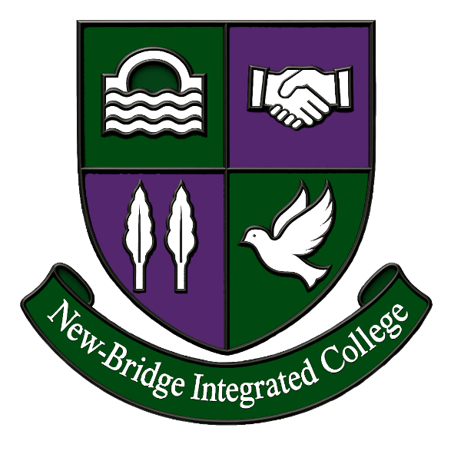

Key Dates
Closing date for receipt of completed applications at 12 noon Friday 24 April 2026
Shortlisted candidates advised of interview date and time on Friday 24 April 2026 evening.
Visit to school offered Wed 29 April from 4pm
Formal Interview Date Friday 1 May 2026

New-Bridge Integrated College
25 Donard View Road
Loughbrickland
Banbridge
BT32 3LN

Tel: 028 406 25010
Email: info@newbridgecollege.loughbrickland.ni.sch.uk

www.newbridgeintegrated.org

‘The School for All the Familiy’

