New-Bridge Integrated College

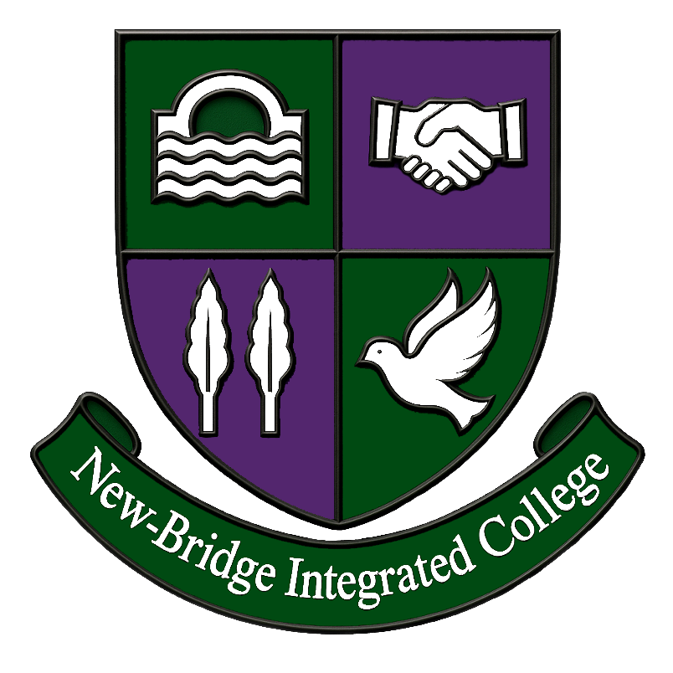

Teacher of ICT /Creative Media

5 Day Post (Maternity)
Effective December 2026

Post Details

New-Bridge Integrated College
is an integrated, all-ability, co-educational 11-18 school

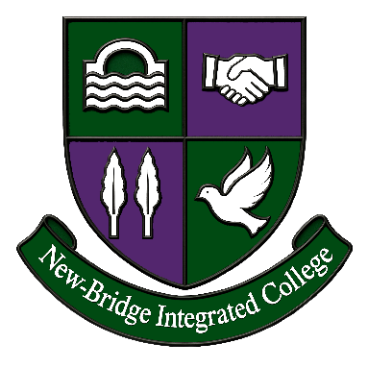

Applications are invited for the following post:

Teacher of
ICT/Creative Media (Maternity)
5-day Post

Further information available from the College website
https://newbridgeintegrated.org/current-vacancies

info@newbridgecollege.loughbrickland.ni.sch.uk
Tel: 028 4062 5010

25 Donard View Road,
Loughbrickland, BT32 3LN

Closing Date: Noon on Wednesday 7 October 2026

Visit to School: Monday 12 October 2026 from 3.30pm

Interviews: Monday 19 October 2026

-The School for All the Family-

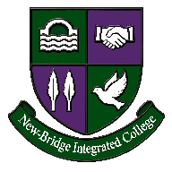
Post: Teacher of ICT/Creative Media (Maternity)
Description: 5 Day Maternity Post

Responsible to: Head of ICT

 | ESSENTIAL | DESIRABLE
QUALIFICATIONS | The criteria that will be applied at shortlisting is as follows: Applicants must hold the following at by 30 June 2026:  - Department of Education recognised teaching qualification, Post Primary ICT related PGCE  - Relevant Degree in ICT/Creative Media  - Be registered GTCNI before taking up the post.  - Minimum Degree Classification 2.2 | Preference may be given to those applicants who:  - Minimum Degree Classification 2.1
EXPERIENCE | The criteria that will be applied at shortlisting is as follows  Applicants must hold the following at 30 June 2026  - Experience of teaching ICT at KS3  - Experience of teaching ICT, Digital Technology and or Creative Media KS4.  - Excellent communication skills as demonstrated on application form  - A clear written statement, expressed in the application form, of how you can support the College’s integrated and inclusive ethos. | - Experience of teaching GCSE /BTEC L3/CTEC Creative Media/ICT  - Evidence of recent professional development relevant to post.  - Evidence of experience and expertise in use of ICT

The Board of Governors reserves the right to enhance the criteria, if necessary, in order to facilitate a manageable shortlist.

Post: Teacher of ICT/Creative Media

Description: 5 Day Post – Effective December 2026

Responsible to: The Head of ICT

We are looking for a Teacher
- To contribute to the teaching of ICT at KS3.
- To contribute to the teaching of ICT and Creative Media at Key Stage 4.
- To contribute to the teaching of GCSE Digital Technology.
- To contribute to the teaching of Creative Media at Key Stage 5.
- To enthuse and motivate students to excel.
- To develop industry links within the department to enhance teaching and learning.
- To attend departmental meetings as required.
- To monitor and evaluate curriculum innovation and delivery.
- To assess and monitor student performance and progress.
- To prepare pupils for internal and external examinations.
- To deliver a second subject (outside of LLW).
- To act as a form teacher with associated pastoral care duties, if applicable.
- To contribute to/participate in extra-curricular activities.
- To undertake supervisory duties, rotas and other duties as required by the Principal.
- To promote the integrated ethos in the day-to-day work of the College.

Teaching & Learning
- To implement a child centred approach to teaching and learning
- To manage pupil learning through effective teaching in accordance with the Curriculum Area’s schemes of work and policies.
- To ensure continuity, progression and cohesiveness in all teaching through effective planning.
- To use a variety of teaching methods and approaches to match curricular objectives and the range of pupil needs.
- To ensure an equal opportunity for all pupils to succeed through the use of differentiation and Assessment for Learning in an all-ability setting.
- To set and mark homework regularly, in accordance with the Department homework policy
- To use the positive management of behaviour in an environment of mutual respect which allows pupils to feel safe and secure and promotes their self esteem

Monitoring, Assessment, Recording, Reporting, and Accountability
- To be responsible for the processes of identification, assessment, recording and reporting for the pupils in their charge.
- To assess pupils’ work systematically and use the results to inform future planning and teaching.
- To be familiar with ICT statutory assessment and reporting procedures and to prepare and present informative, helpful and accurate reports to parents.
- To attend Parents Consultation Meetings, as required.
- To keep an accurate register of pupils for each lesson.
- To undertake any reasonable task as directed by the Subject Team Leader.

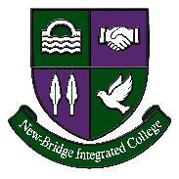
ICT and Creative Media Department Overview

Curriculum
ICT and Creative Media form an important and growing part of the curriculum at New-Bridge Integrated College. All pupils in Years 8, 9 and 10 receive a weekly ICT lesson, developing their digital literacy, creativity, computational thinking and confidence in using technology. The Key Stage 3 curriculum includes online safety, digital productivity, graphic design, website development, programming, multimedia production, data handling and emerging technologies.
At Key Stage 4, pupils can continue their studies through a range of academic and vocational pathways, including CCEA GCSE Digital Technology, BTEC Level 2 ICT and BTEC Level 2 Creative Media Production. In Sixth Form, the Department offers OCR Cambridge Technical Level 3 IT and the Pearson BTEC Level 3 National Extended Certificate in Creative Digital Media Production.
The successful candidate’s timetable will include classes in Years 8, 10, 11, 12 and 14, with the teaching of Key Stage 4 and Key Stage 5 courses forming a particular priority.
The Department aims to equip pupils with the knowledge, practical skills and confidence required to participate successfully in an increasingly digital society. We encourage pupils to become creative, responsible and independent users of technology who can solve problems, communicate effectively and produce high-quality digital outcomes. Pupils are provided with opportunities to explore areas such as programming, web development, digital media, graphic design, video production, data, networks, cyber security, artificial intelligence and emerging technologies.
Across the curriculum, we endeavour to reflect the College’s all-ability, integrated ethos. We work closely with the Special Educational Needs Department to ensure that appropriate support, differentiation and scaffolding are provided, enabling all pupils to access the curriculum and make progress.

Assessment
The Department operates consistent homework, marking and assessment policies to maintain a standardised approach to formative, diagnostic and summative assessment. Pupils receive regular positive and constructive feedback that enables them to recognise their strengths, address areas for improvement and take responsibility for their progress.
A range of assessment methods is used, including practical projects, digital portfolios, classwork, coursework, controlled assessment and examination-style questions. At Key Stages 4 and 5, departmental tracking, internal moderation and regular review of pupil performance support the effective delivery of both examined and internally assessed units.
Parents and carers are kept informed through two written reports and an individual parent interview. An effective Year Book system is also used to communicate with tutors and parents.

Ethos
The ICT and Creative Media Team values its central role in realising the aims of the College Mission Statement. We believe strongly in positive discipline and strive to create a child-centred, inclusive and supportive approach to teaching, learning and behaviour management.
The Department promotes the College values of being Ready, Respectful and Responsible, including responsible digital citizenship, online safety and the ethical use of technology. We aim to create a learning environment in which pupils feel confident to experiment, solve problems, collaborate and learn from their mistakes.
Oral commendation and “Good Comments” are used to motivate and reward pupils who work hard, make progress, demonstrate creativity or contribute positively to the Department. “Good Comments” also allow teachers to recognise pupils who are helpful, supportive of others or involved in departmental and extracurricular activities.

Staff
There are currently three teachers delivering the ICT and Creative Media curriculum, supported by a dedicated ICT technician. The team works closely together in a supportive and collaborative manner, sharing resources, planning learning, monitoring pupil progress and maintaining consistent standards across the Department.
The Department is committed to continuous improvement and embraces new technologies, teaching approaches and opportunities for professional development. Staff also provide additional support for pupils through coursework guidance, examination preparation, revision sessions and extracurricular activities.

Facilities
New-Bridge Integrated College moved into its new school building in June 2025, and the ICT and Creative Media Department has benefited from excellent modern facilities.
The Department has three specialist ICT rooms equipped with state-of-the-art desktop computers and a wide range of professional software, including Adobe Creative Suite. These facilities provide an excellent environment for the delivery of both technical and creative subjects, supporting areas such as programming, website development, graphic design, digital imaging, animation, video production and digital portfolio work.
The combination of modern facilities, specialist software and dedicated technical support enables the Department to deliver a broad, engaging and innovative curriculum across Key Stages 3, 4 and 5.

Teacher of
ICT/Creative Media 5-day Post (Maternity)



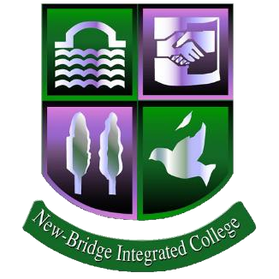
Application must be received by: Noon on Wednesday 7 October 2026
New
-
Bridge Integrated College

Tel:

028

406 25010

info@newbridgecollege.loughbrickland.ni.sch.uk
1. PERSONAL INFORMATION
Salutation
Forename(s)
Surname
Address including postcode
Contact telephone numbers  Email address  Teacher  Reference  Number  Are you registered with the General TeachingCouncil (NI)? | Home:  Mobile:
Yes/No

GTCNI No:

2. SECONDARY EDUCATION
GCSE Subjects (or equivalent) | Grades
A Level Subjects (or equivalent) | Grades

3. FURTHER/HIGHER EDUCATION AND PROFESSIONAL QUALIFICATIONS
Name of Institute Dates Course Followed |  |  | Qualification  (Including level)

4. PROFESSIONAL DEVELOPMENT IN THE LAST 3 YEARS (relevant to Post)
Please list any relevant Professional Development (includes School INSET)

5. EMPLOYMENT HISTORY AND EXPERIENCE
Present post – Date of Appointment  Incl. school name  enrolment number |  | Details of Position and Held and Teaching Allowances if Applicable
Previous posts –  Start with the most recent and include the name of the school and enrolment number |  | Details of Position(s) Held and Teaching Allowances if Applicable
Please account for any gaps in Please account for any gaps in your employment record. If there are none, then simply state ‘none’.
6. ESSENTIAL AND DESIRABLE CRITERIA
You should use this section to demonstrate clearly, with examples, how you meet each aspect of Essential Criteria and aspects of Desirable Criteria required for the post.
The Recruitment and Selection Panel will assess these from the information provided

ESSENTIAL AND DESIRABLE CRITERIA (cont’d)

7. SAFEGUARDING
A security check will be performed on the successful candidate and failure to disclose convictions, spent or unspent, which are subsequently discovered may lead to dismissal or disciplinary action. Any appointment by the College will be subject to this security check not finding anything that would prevent an individual working with children or vulnerable adults. Any information given will be treated as strictly confidential and will be considered only in relation to the application for this position for which such an exemption is appropriate.

Is there any reason why you would not be suitable to work with children and young people in an educational environment? | YES/NO
8. ARRANGEMENTS FOR INTERVIEW
Do you require any arrangements to be made for you to attend an interview? | YES/NO
If YES, please outline the nature of what these arrangements would be
9. REFERENCES
Please give the names of two referees, both of whom should be able to comment on your professional work and one must be your current employer. References will only be requested once shortlisting has been confirmed. Prior consent of referees should be obtained.
Name  School  Position  Address |  | Name  School
Name  School  Position  Address |  | Position
Name  School  Position  Address |  | Address
Tel  Email |  | Tel  Email

10. DECLARATION
NOTE | The employer reserves the right only to interview candidates who meet the criteria established for the post on the basis of information supplied on the application form. New-Bridge Integrated College will manage your data in compliance with the requirements of the GDPR. Your application form will be held in a manual and electronic filing system in the School Business Manager’s Office for a period of one year following the closing date for applications. After this period your application will be destroyed as confidential waste.  By completing and signing this application form you are consenting to the information supplied by you being held as outlined above.
This information will not be disclosed to a third party unless required to do so by law.
Any applicant found to have knowingly given false or inaccurate information or to have wilfully failed to disclose any relevant fact, will be excluded from the recruitment process or may be dismissed.
Canvassing will disqualify.
DECLARATION | I give the College the right to investigate all references and to secure additional information about me, provided it is related to my application for this post. I hereby release from liability the College and its representatives for seeking such information and all other persons, corporations, or organisations for furnishing such information.  I have read and understood the requirements and particulars of the appointment which have been supplied to me. I further understand that the job offer will be subject to the satisfactory outcome of a security check, social media check, references and/or a pre-employment health assessment and I consent to my doctor being approached for further information, including medical reports, if the College considers it necessary.
Signature of Candidate:

Date:
THIS FORM MUST BE PRINTED AND SIGNED BEFORE SUBMISSION OR A DIGITAL IMAGE OF YOUR SIGNATURE INSERTED BEFORE EMAILING IT TO THE COLLEGE.
The completed form should be returned to info@newbridgecollege.loughbrickland.ni.sch.uk by
noon on Wednesday 7 October 2026. Late applications will not be considered.

Visit to School: from 3.30pm on Monday 12 October 2026
Interviews to take place on Monday 19 October 2026

New-Bridge Integrated College

EQUAL OPPORTUNITIES MONITORING QUESTIONNAIRE

Ref: NB – ICTMAT/26

Job Title: Teacher of ICT and Creative Media - Maternity Cover

PRIVATE & CONFIDENTIAL
GUIDANCE NOTES
We are an Equal Opportunities employer. We aim to provide equality of opportunity to all persons regardless of their religious belief; political opinion; sex; race; age; sexual orientation; or, whether they are married or in a civil partnership; or whether they are disabled; or whether they have undergone, are undergoing or intend to undergo gender reassignment.
We do not discriminate against our job applicants or employees on any of the grounds listed above. We aim to select the best person for the job and all recruitment decisions will be made objectively.
In this questionnaire we will ask you to provide us with some personal information about yourself. We are doing this for two reasons.
Firstly, we are doing this to demonstrate our commitment to promoting equality of opportunity in employment. The information that you provide us will assist us to measure the effectiveness of our equal opportunity policies and to develop affirmative or positive action policies.
Secondly, we also monitor the community background and sex of our job applicants and employees in order to comply with our duties under the Fair Employment & Treatment (NI) Order 1998.
You are not obliged to answer the questions on this form and you will not suffer any penalty if you choose not to do so.
Nevertheless, we encourage you to answer the questions below. Your identity will be kept anonymous and your answers will be treated with the strictest confidence. We assure you that your answers will not be used by us to make any unlawful decisions affecting you, whether in a recruitment exercise or during the course of any employment with us. To protect your privacy, you should not write your name on this questionnaire. The form will carry a unique identification number and only our Monitoring Officer will be able to match this to your name.

PLEASE COMPLETE THE FOLLOWING SECTIONS: TICK BOXES AS APPROPRIATE.
New-Bridge Integrated College Monitoring Returns Form

MONITORING QUESTIONNAIRE
Private & Confidential

New-Bridge Integrated College will seek to ensure that all existing and potential employees are given equal opportunities. It is committed to equality of opportunity in its employment policies. The aim is to promote equality of opportunity so that no employee or potential employee will be subject to unlawful or unfair discrimination on the grounds of gender, age, marital status, colour, race, nationality or other ethnic or national origin, disability, religion or sexual relationship. New-Bridge Integrated College will seek to ensure that no applicant for employment is disadvantaged by conditions or requirements which cannot be justified.

To demonstrate our commitment to equality of opportunity in employment we need to monitor the gender and community background of our applicants and employees in accordance with the requirements specified by the Fair Employment and Treatment (NI) Order 1998 (and for no other reason).
This information is confidential, will not be taken into account during the application process or when making the appointment. .

Regardless of whether we practice religion, most of us in Northern Ireland are seen as either Roman Catholic or Protestant. We are therefore asking you to indicate your community background by ticking the appropriate box below.

I am a member of the Protestant community

I am a member of the Roman Catholic community

I am a member of neither the Protestant nor Roman Catholic community

Please indicate whether you are: Female Male I prefer not to say

Office use only
Candidate Reference Number

